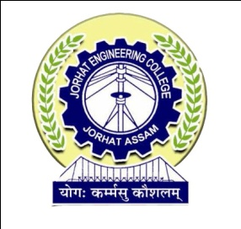

**DEPARTMENT OF COMPUTER APPLICATION**

**JORHAT ENGINEERING COLLEGE, JORHAT**

## **CERTIFICATE**

This is to certify that the project work entitled “MATERIALS STOCK MANAGEMET SYSTEM FOR JORHAT ELECTRICAL CIRCLE OF APDCL” is an authentic work carried out at APDCL,JORHAT ELECTRICL CIRCLE, Jorhat is an approved work done by TRINAYAN SANKAR DAS (Roll No- 13220019, Reg.No-1201 of 2013-2014), a 6th Semester MCA student of Jorhat Engineering College, Jorhat, for the partial fulfillment of the requirement for the award of the degree of Master of Computer Application under Dibrugarh University, Dibrugarh from Jorhat Engineering College, Jorhat.

I wish his success in all future endeavours.

Date:

### (External Examiner)